**Sprint -7 Dotnet with cloud batch**

**Sprint date – 4th to 15th of November, 2019**

**Topic - Document for Deploying the Web Application Programming Interface Project in Azure**

**Group D: Inventory Management**

* **Function App**

Creation of Function app on Microsoft Azure. We search the function app from all the types of services provided by Azure and then select the function app and then proceed.

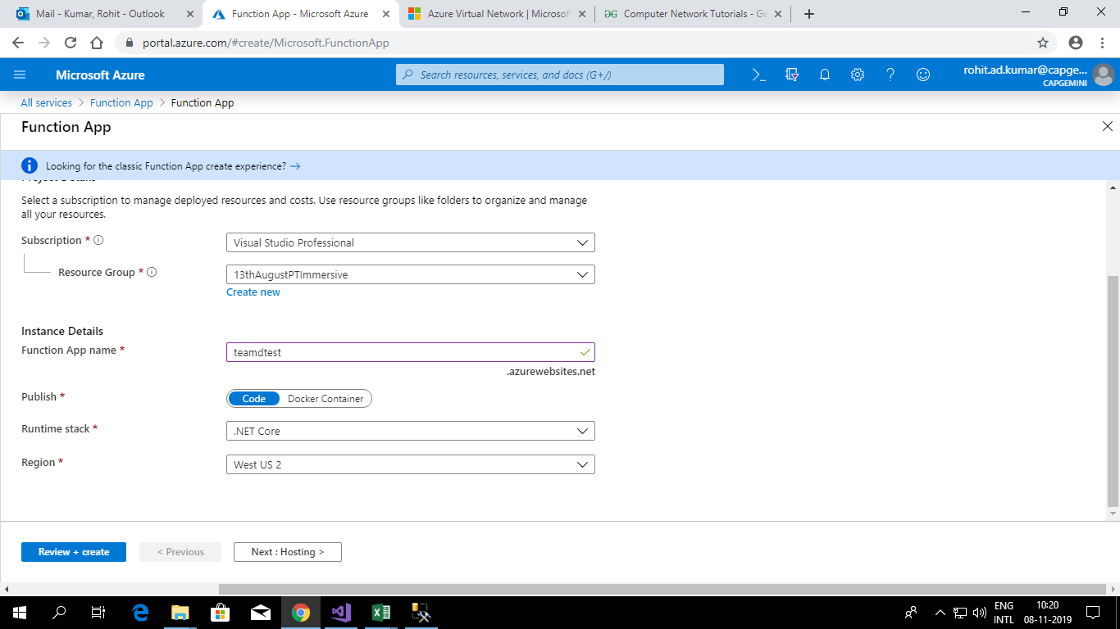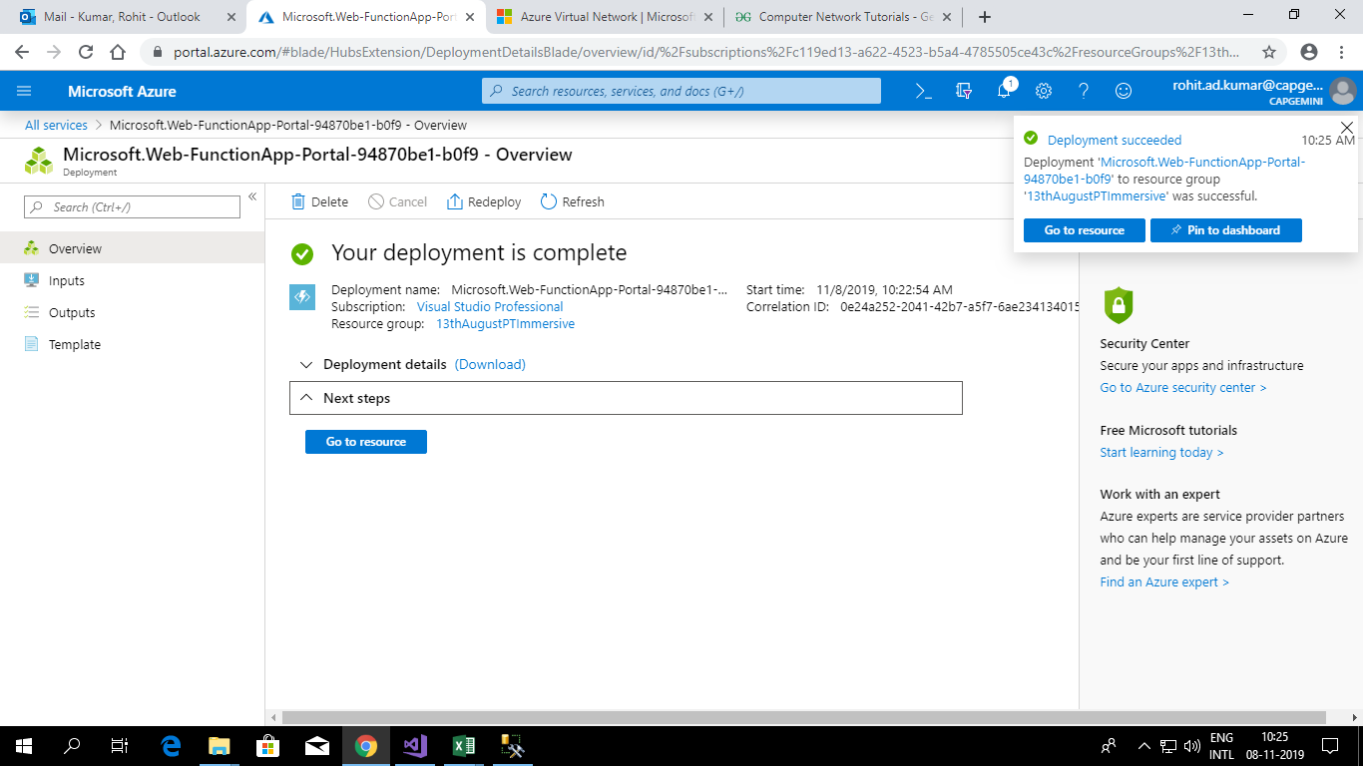 **Create a function app**

1. From the **Azure** portal menu, select a resource.
2. In the New page, select Compute > **Function App**.
3. Use the **function app** settings as specified in the table below the image. ...
4. Enter the following settings for hosting. ...
5. Enter the following settings for monitoring. ...
6. Select Create to provision and deploy the **function app**

* **Cognitive services**
* Creation of Cognitive services on Azure.
* **Azure Cognitive Services** are APIs, SDKs, and **services** available to help developers build intelligent applications without having direct AI or data science skills or knowledge.
* Cognitive services are the set of machine learning algorithms.

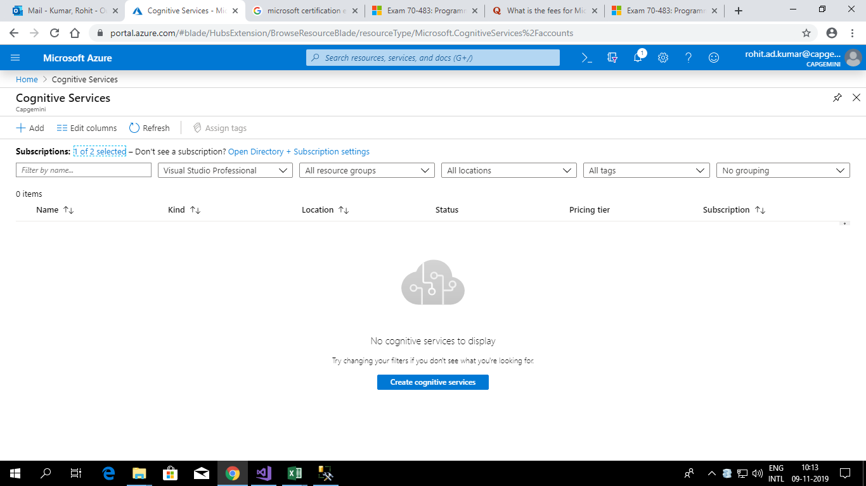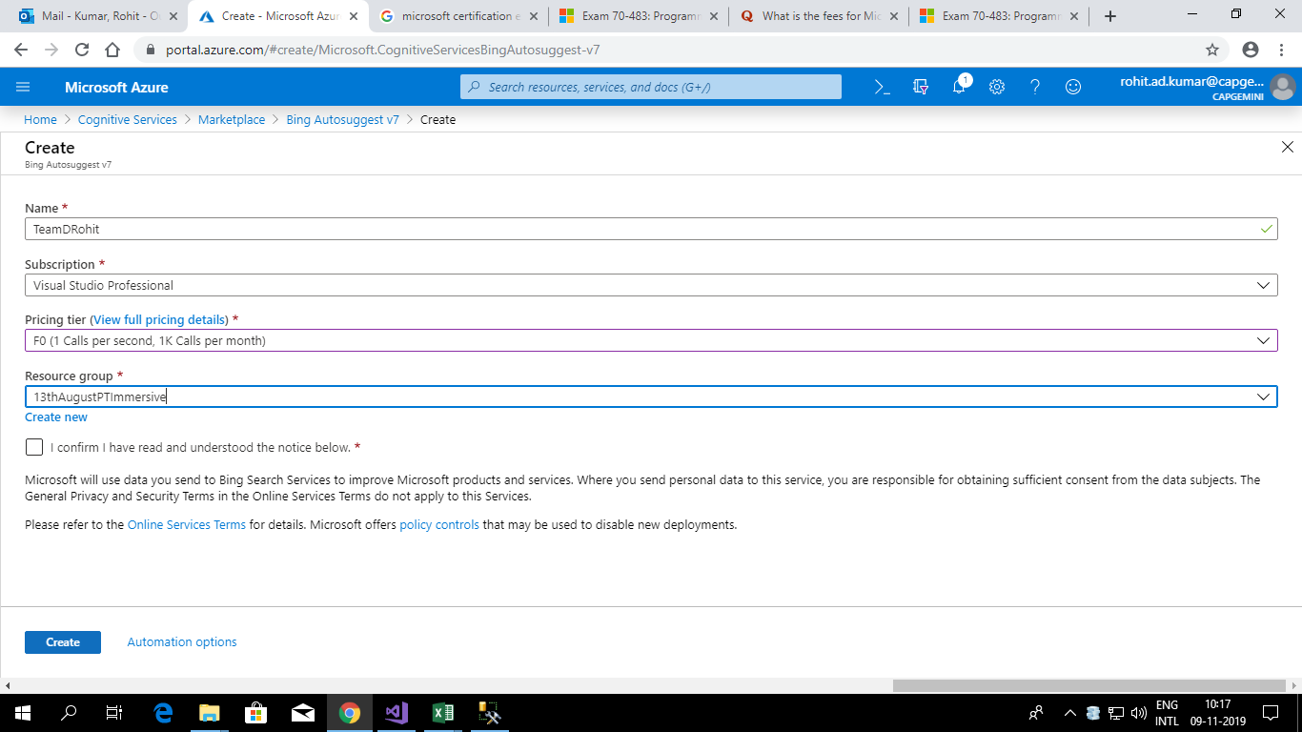

* **Create Storage Account**

In the AZURE **STORAGE** explorer, right-click on your subscription and choose **Create Storage Account**. Type a globally unique name for your **Storage Account** and press Enter. Valid characters for an app name are 'a-z' and '0-9'. **Create** a new Resource Group and accept the default name.

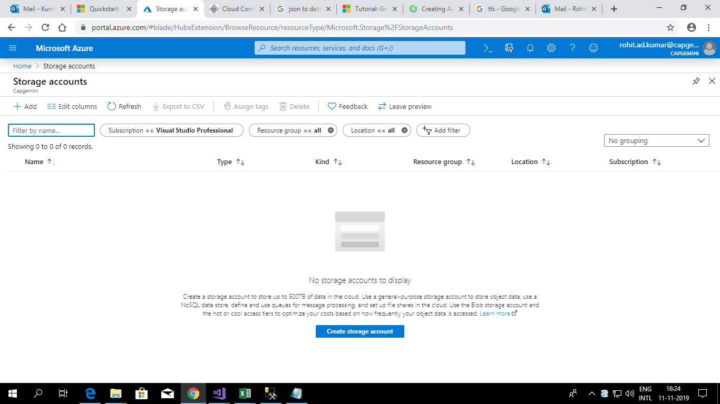

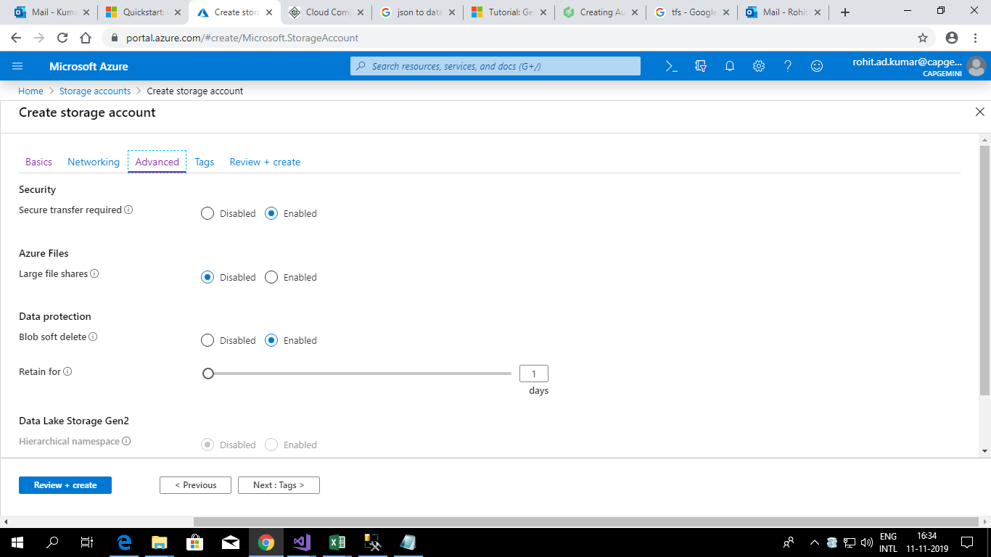

* **Create Logic App to create queue and Table**

1. Create your **logic app**.
2. Add queue name
3. Add table name with properties.
4. Create a queue and after the time interval it can be saved in the table.

